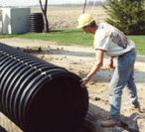

ADS N-12 Corrugated

HDPE Drain Pipes

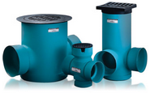

Nyloplast Drain Basins

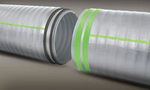

Sanitite HP Sewer Pipes

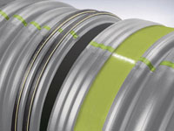

HP Storm Polypropylene Pipes

ADS Duraslot Lateral Drains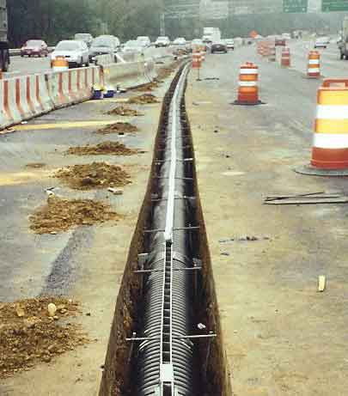DURASLOT Drain Pipes

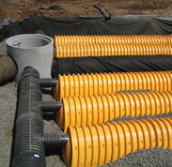

STORMTECH Chamber for

Retention/Detention Systems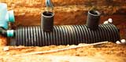

ADS Water Quality Units

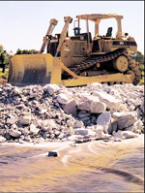

ADS Geotextiles and Grids

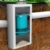

Hydro International

Hydrodynamic Separator

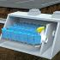

Hydro International

Filtration Units

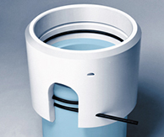

NASP Restraint PVC Pipes

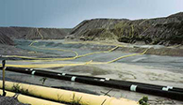

NASP Yelomine Restraint Pipes

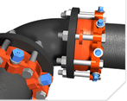

EBAA Pipe Restraint



GARLOCK Gaskets

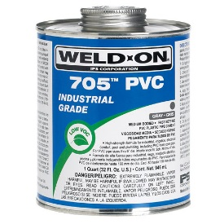

IPS Weld On Primers and Cement



Multi Fittings PVC Fittings

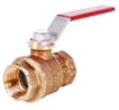

Legend Valves and Fittings

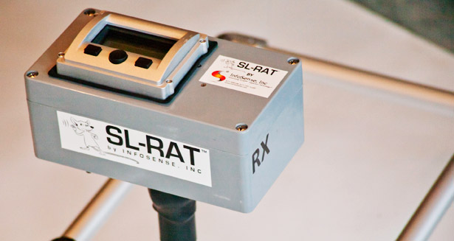

INFOSENSE SL-RAT Sewer Line Rapid Assessment Tool

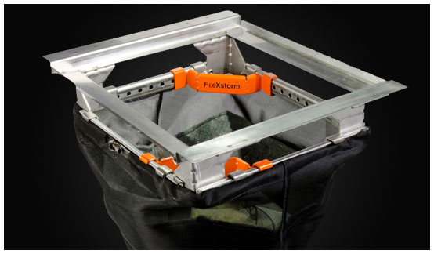

FLEXSTORM Inlet Filters